**HTML Basic**

**HTML Examples:**

In this chapter we will show some basic HTML examples.

Don't worry if we use tags, you have not learned about yet.

**HTML Documents:**

All HTML documents must start with a document type declaration

The HTML document itself begins with <html> and ends with </html>.

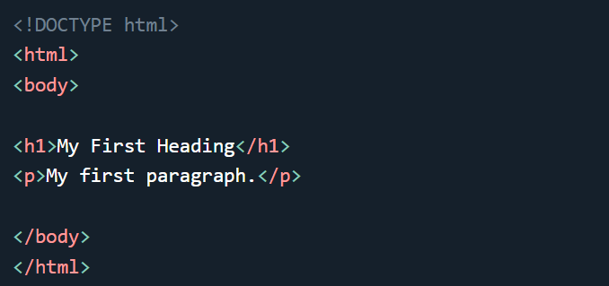The visible part of the HTML document is between <body> and </body>.

**The <!DOCTYPE> Declaration:**

The <!DOCTYPE> declaration represents the document type, and helps browsers to display web pages correctly.

It must only appear once, at the top of the page (before any HTML tags).

The <!DOCTYPE> declaration is not case sensitive.

The <!DOCTYPE> declaration for HTML5 is:

* <!DOCTYPE html>

**HTML Headings:**

HTML headings are defined with the <h1> to <h6> tags.

<h1> defines the most important heading. <h6> defines the least important headings.

**Code:**

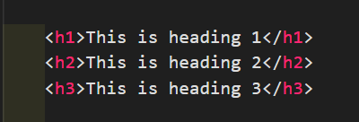

**Output:**

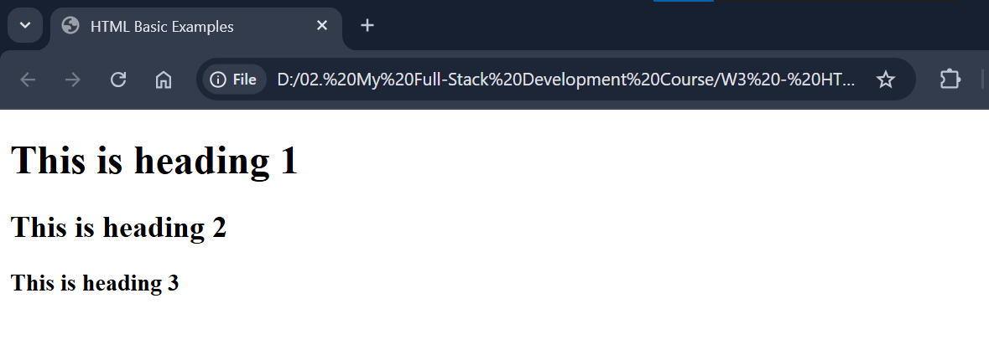

**HTML Paragraphs:**

HTML paragraphs are defined with the <p> tag:

**Code:**

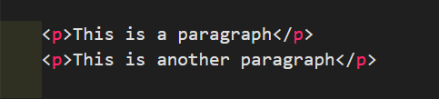

**Output:**

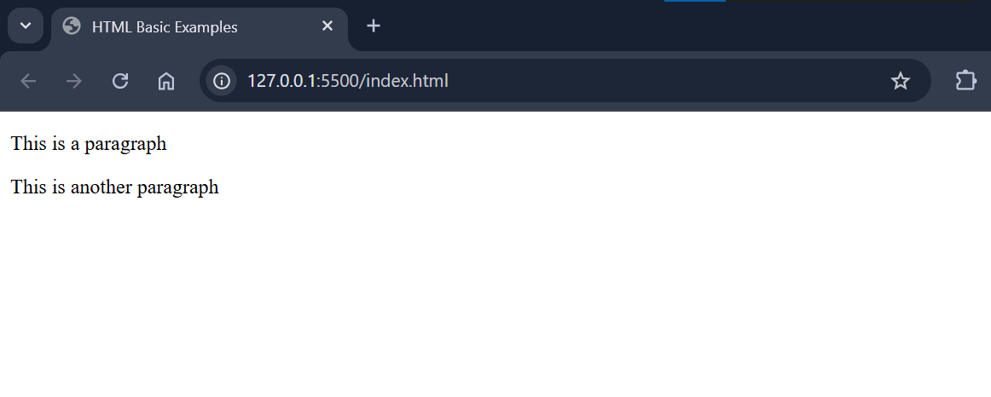

**HTML Links:**

HTML links are defined with the <a> tag:

**Code:**



**Output:**

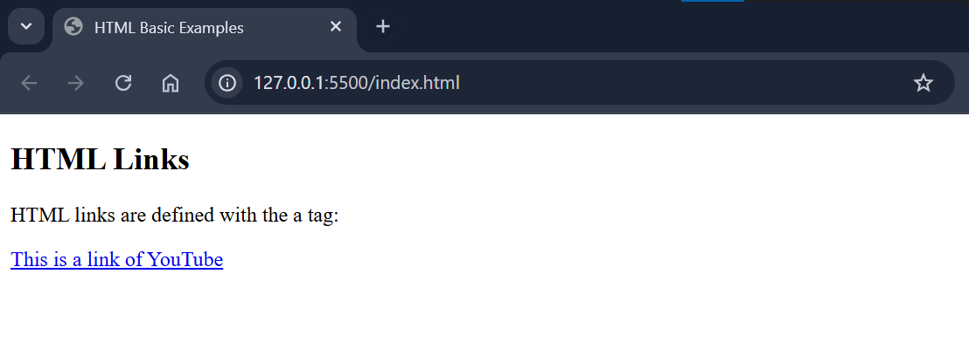

**HTML Images:**

HTML images are defined with the <img> tag.

The source file (src), alternative text (alt), width, and height are provided as attributes:

**Code:**



**Output:**

